ACSF qualification summary for:
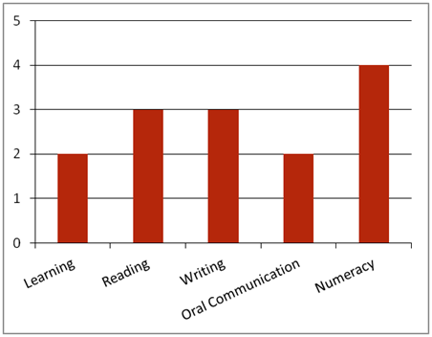FPP50110 Diploma of Pulp and Paper Process Management
Note: This graph provides summary information only. For detail, refer to the ACSF Skill indicator table below.
This qualification is designed for job roles in the forest and forest products industry.
Key foundation skills for this qualification
Learning skills to identify and action problems that arise, within scope of own responsibility; and apply some prior knowledge to access and navigate computer systems.
- Training activities in this area could support the delivery of FSKLRG05 Use strategies to plan simple workplace tasks
Reading skills to identify and comprehend key information in familiar OHS, environmental, safe working, legislative and organisational requirements for calculating and analysing production and financial performance; use explicit strategies to make connections between reports and relevant financial data.
- Training activities in this area could support the delivery of FSKRDG07 Read and respond to simple workplace information, FSKRDG06 Read and respond to routine simple informal workplace texts or FSKRDG05 Read and respond to simple workplace information.
Writing skills to enter computer-based information; produce record of financial performance analysis; and produce performance and activity reports within the required format.
- Training activities in this area could support the delivery of FSKWTG06 Write simple workplace information or FSKWTG09 Write routine workplace texts.
Oral communication skills to use appropriate communication methods with others while calculating and analysing financial performance.
- Training activities in this area could support the delivery of FSKOCM03 Participate in simple spoken interactions at work.
Numeracy skills to calculate and verify calibration calculations such as division, addition, percentages and ratios; use mathematical concepts related to equipment calibration; calculate calibration adjustments such as weight, volume, temperature and length; interpret times series data to identify performance trends; analyse and prepare data appropriately, in tables, spreadsheets, graphs, plots, using measures of central tendency; analyse financial results to identify financial areas for improvement; calculate and compare costs with standard budgets; identify variances; calculate actual performance; calculate yield, wastage and productivity; and use recording tools such as statistical process charts and production tally sheets.
- Training activities in this area could support the delivery of FSKNUM22 Use and apply ratios, rates and proportions for work or FSKNUM21 Apply an expanding range of mathematical calculations for work.

ACSF Skill indicators
Core units |  | Learning |  | Reading |  | Writing |  | Oral Comm |  | Numeracy
FPPNUM430A | Calculate and analyse production and financial performance | 2.01 | 2.02 | 3.03 | 3.04 | 3.05 | 3.06 | 2.07 | 2.08 | 4.09 | 4.10 | 4.11
FPPOHS420A | Manage OHS processes | Not mapped as part of this project.
FPPPLN420A | Plan a complex activity
FPPQAS430A | Oversee quality assurance process
FPPSUS510A | Develop workplace policy and procedures for sustainability
Performance Variables
Level 2 simple familiar texts and vocabulary with clear purpose; with support available if requested; a limited range of contexts; and limited steps in the work process.
Level 3 routine texts; working independently in a range of familiar contexts in tasks involving a number of steps in the work process.
Level 4 complex texts; works independently and initiates and uses support, in a range of contexts including unfamiliar or unpredictable and complex task organisation and analysis in the work process.

