ACSF qualification summary for:
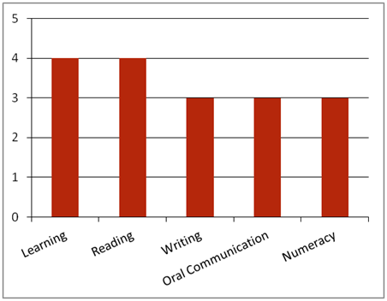FPI40411 Certificate IV in Timber Truss and Frame Design
Note: This graph provides summary information only. For detail, refer to the ACSF Skill indicator table below.
This qualification is designed for job roles in the timber processing sector of the forest and forest products industry, such as Designer (Timber Truss & Frame).
Key foundation skills for this qualification
Learning skills to monitor and assess workplace hazards, SHE issues and risks; analyse work practices and processes to identify areas for improvement; determine and implement changes to work practices and processes to improve SHE concerns; monitor emergency and evacuation procedures; monitor community and organisational environmental goals, training and operational controls and environmental measures; conduct progress reviews to assess impact on the environment; identify and rectify problems and equipment faults; apply, monitor and coordinate quality system procedures to work; check and coordinate product specifications; monitor and direct material grading.
- Training activities in this area could support the delivery of FSKLRG12 Apply strategies and manage complex workplace tasks or FSKLRG13 Apply strategies to respond to complex workplace problems.
Reading skills to Identify and follow relevant OHS, SHE, environmental, legislative and organisational requirements and policies related to the role; check SHE or incident reports; interpret environmental management systems that detail compliance, improvement and prevention.
- Training activities in this area could support the delivery of FSKRDG11 Read and respond to complex workplace information.
Writing skills to record and report quality and product care procedures and product specifications and equipment and machinery; record SHE procedures; record community and organisational environmental goals.
- Training activities in this area could support the delivery of FSKWTG06 Write simple workplace information or FSKWTG09 Write routine workplace texts.
Oral communication skills to establish and maintain communication with others by using verbal and non-verbal language, constructive feedback, control of tone of voice, culturally and socially appropriate language; report hazards, SHE issues and concerns to appropriate personnel; make suggestions to appropriate personnel about lessons learnt and changes required; report quality and product care procedures, report machinery and equipment maintenance.
- Training activities in this area could support the delivery of FSKOCM03 Participate in simple spoken interactions at work or FSKOCM07 Interact effectively with others at work.
Numeracy skills to estimate and measure, calculate time required to complete task; monitor machinery and equipment; check product specifications; monitor and record community and organisational goals which include material, energy and other resource use, emissions control and reduction, waste generation, control and reduction; conduct progress reviews and assess environmental impact including magnitude or degree, frequency, likelihood, duration and geographic area.
- Training activities in this area could support the delivery of FSKNUM15 Estimate, measure and calculate with routine metric measurements for work or FSKNUM14 Calculate with whole numbers and familiar fractions, decimals and percentages for work.
ACSF Skill indicators
Core units |  | Learning |  | Reading |  | Writing |  | Oral Comm |  | Numeracy
FPICOR4201B | Monitor safety, health and environment policies and procedures | 4.01 | 4.02 | 4.03 | 4.04 | 3.05 | 3.06 | 3.07 | 3.08 | 3.09 | 3.10 | 3.11
FPICOR4203B | Monitor quality and product care procedures | 3.01 | 3.02 | 2.03 | 2.04 | 2.05 | 2.06 | 2.07 | 2.08 | 2.09 | 2.10 | 2.11
Performance Variables
Level 2 simple familiar texts and vocabulary with clear purpose; with support available if requested; a limited range of contexts; and limited steps in the work process.
Level 3 routine texts; working independently in a range of familiar contexts in tasks involving a number of steps in the work process.

