ACSF qualification summary for:
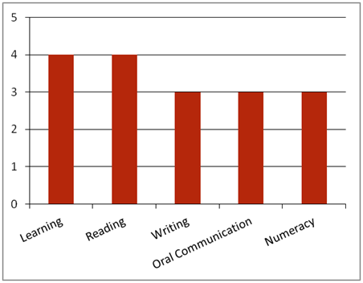FPI40111 Certificate IV in Forest Operations
Note: This graph provides summary information only. For detail, refer to the ACSF Skill indicator table below.
This qualification has eight employment pathways for typical forest operations environments, including:
• Arboriculture Supervisor
• Farm Forestry Supervisor
• Forestry Supervisor
• Forestry Operations Supervisor
• Harvesting Supervisor
• Harvesting Team Leader
• Propagation and Stand Health Supervisor
• Tree Farm Supervisor.
Key foundation skills for this qualification
Learning skills to identify and prioritise work tasks; monitor and control workplace hazards and risks, including fire hazards; evaluate and respond to fires; monitor training and operational controls; plan and monitor evacuation procedures; review organisational plans and site practices for areas of improvement; develop new systems to increase effectiveness; implement new work practices to improve SHE concerns; apply, monitor and coordinate quality system procedures to work; monitor and direct material grading.
- Training activities in this area could support the delivery of FSKLRG12 Apply strategies and manage complex workplace tasks or FSKLRG13 Apply strategies to respond to complex workplace problems.
Reading skills to identify, interpret and follow relevant OHS, environmental, legislative and organisational requirements relevant to the job role; analyse forestry operation requirements; check SHE or incident reports; inspect weather conditions; examine and interpret environmental management systems that detail compliance, improvement and prevention; review operational plan.
- Training activities in this area could support the delivery of FSKRDG11 Read and respond to complex workplace information.
Writing skills to record and report quality and product care procedures and product specifications and equipment and machinery; record and report workplace information; report potential fires; record community and organisation environmental goals; record recommendations for improvements; record forestry operation procedures; record SHE procedures.
- Training activities in this area could support the delivery of FSKWTG06 Write simple workplace information or FSKWTG09 Write routine workplace texts.
Oral communication skills to establish and maintain communication with others using verbal and nonverbal language, constructive feedback, control of voice and appropriate language; report hazards and concerns; make suggestions to appropriate personnel about possible improvements required; consult with appropriate personnel to introduce change; report forestry operations which may include information on OHS policies, quality outcomes and technology requirements; report potential fires to relevant personnel: report quality and product care procedures; report machinery and equipment maintenance requirements.
- Training activities in this area could support the delivery of FSKOCM03 Participate in simple spoken interactions at work or FSKOCM07 Interact effectively with others at work.
Numeracy skills to estimate, measure and calculate time required to complete tasks; monitor machinery and equipment; check product specifications; inspect weather reports for change in temperatures and conditions; review operational plans and site practices in relation to energy consumption, carbon emissions ad material consumption; assess impact of improvements on the environment; monitor and record community and organisational environmental goals, including use of materials, energy and other resources, emissions control and reduction, waste generation, control and reduction; conduct progress reviews and assess environmental impact including magnitude or degree, frequency, likelihood, duration and geographic area.
- Training activities in this area could support the delivery of FSKNUM14 Calculate with whole numbers and familiar fractions, decimals and percentages for work, FSKNUM15 Estimate, measure and calculate with routine metric measurements for work.
ACSF Skill indicators
Core units |  | Learning |  | Reading |  | Writing |  | Oral Comm |  | Numeracy
FPICOR3203B | Evaluate fire potential and prevention | 3.01 | 3.02 | 2.03 | 2.04 | 3.05 | 3.06 | 2.07 | 2.08 | 2.09 | 2.10 | 2.11
FPICOR4201B | Monitor safety, health and environment policies and procedures | 4.01 | 4.02 | 4.03 | 4.04 | 3.05 | 3.06 | 3.07 | 3.08 | 3.09 | 3.10 | 3.11
FPICOR4202B | Monitor and review forestry operations | 4.01 | 4.02 | 4.03 | 4.04 | 3.05 | 3.06 | 3.07 | 3.08 | 3.09 | 3.10 | -
FPICOR4203B | Monitor quality and product care procedures | 3.01 | 3.02 | 2.03 | 2.04 | 2.05 | 2.06 | 2.07 | 2.08 | 2.09 | 2.10 | 2.11
Performance Variables
Level 2 simple familiar texts and vocabulary with clear purpose; with support available if requested; a limited range of contexts; and limited steps in the work process.
Level 3 routine texts; working independently in a range of familiar contexts in tasks involving a number of steps in the work process.

