ACSF qualification summary for:
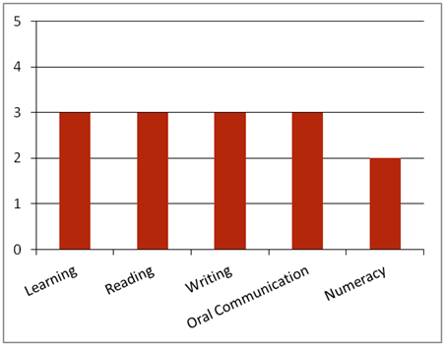FPI30911 Certificate III in Timber Truss and Frame Design and Manufacture
Note: This graph provides summary information only. For detail, refer to the ACSF Skill indicator table below.
This qualification has two employment pathways for typical operational environments of timber truss and frame design. These are:
• Designer (Timber Truss & Frame)
• Production Fabricator (Timber Truss & Frame).
Key foundation skills for this qualification
Learning skills to identify and prioritise work tasks; select and use appropriate equipment; organise duties, equipment and materials according to SHE requirements; carry out workplace procedures to company requirements; maintain machinery and equipment; assess and rectify familiar material and production problems; propose and provide changes to work processes; minimise waste through planning; identify and follow correct procedures and processes for meetings; and identify and establish opportunities for professional development.
- Training activities in this area could support the delivery of FSKLRG05 Use strategies to plan simple workplace activities, FSKLRG09 Use strategies to respond to routine work problems or FSKLRG11 Use routine strategies for work related learning.
Reading skills to identify key information in OHS, environmental, legislative and organisational requirements; interpret work orders, signage and visual communication; access and interpret information from a range of sources, including company procedures, checklists, instructions and bulletins; and identify and apply customer product specifications and requirements.
- Training activities in this area could support the delivery of FSKRDG07 Read and respond to simple workplace information, FSKRDG06 Read and respond to routine simple informal workplace texts or FSKRDG05 Read and respond to simple workplace information.
Writing skills to convey instructions using communication modes such as email, fax and internet; respond to verbal and written instructions using memos, MSDS, charts and plans; complete incident reports, environmental, hazards and SHE reports; record and report quality and product care procedures; note meetings goals and outcomes; and record learning and competency development information.
- Training activities in this area could support the delivery of FSKWTG06 Write simple workplace information or FSKWTG09 Write routine workplace texts.
Oral communication skills to check legal and procedural requirements, own work role and responsibilities with appropriate personnel; receive, respond to and convey instructions accurately; conduct verbal reporting; report risks, hazards and SHE issues; participate in simple meeting processes; seek feedback on performance and appropriate support and mentoring; communicate with co-workers using language and mannerisms that are socially and culturally acceptable; and apply visual communications.
- Training activities in this area could support the delivery of FSKOCM03 Participate in simple spoken interactions at work or FSKOCM07 Interact effectively with others at work.
Numeracy skills to access and interpret delivery dockets, graphical instructions, charts, MSDS, maps, diagrams, work schedules and job risk assessments; apply visual communications using electronic and mechanical signals; and estimate, measure and calculate time required to complete tasks.
- Training activities in this area could support the delivery of FSKNUM09 Identify, measure and estimate familiar quantities for work, FSKNUM11 Read and use familiar maps and plans and diagrams for work.
ACSF Skill indicators
Core units |  | Learning |  | Reading |  | Writing |  | Oral Comm |  | Numeracy
FPICOR2201B | Work effectively in the forest and forest products industry | 2.01 | 2.02 | 2.03 | 2.04 | 2.05 | 2.06 | 3.07 | 3.08 | - | - | -
FPIC0R2202B | Communicate and interact effectively in the workplace | 2.01 | 2.02 | 2.03 | 2.04 | 2.05 | 2.06 | 3.07 | 3.08 | 2.09 | 2.10 | -
FPICOR3201B | Implement safety, health and environment policies and procedures | 3.01 | 3.02 | 3.03 | 3.04 | 3.05 | 3.06 | 3.07 | 3.08 | 2.09 | 2.10 | 2.11
FPICOR3202B | Conduct quality and product care procedures | 2.01 | 2.02 | 2.03 | 2.04 | 2.05 | 2.06 | 2.07 | 2.08 | 2.09 | 2.10 | -
Performance Variables
Level 2 simple familiar texts and vocabulary with clear purpose; with support available if requested; a limited range of contexts; and limited steps in the work process.
Level 3 routine texts; working independently in a range of familiar contexts in tasks involving a number of steps in the work process.

