ACSF qualification summary for core units of:
FPI30111 Certificate III in Forest Growing and Management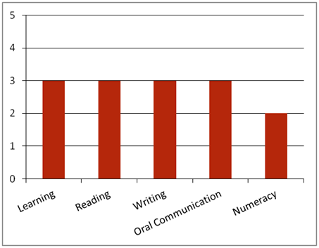
Note: This graph provides summary information only. For detail, refer to the ACSF Skill indicator table below.
This qualification is designed for operational job roles in the forest growing and management sector of the forest and forest products industry.
Key foundation skills for this qualification
Learning skills to identify and prioritise work tasks; select and use appropriate equipment; identify and establish opportunities for professional development; identify and follow correct procedures and processes; organise duties, equipment and materials according to SHE requirements; propose and provide changes to work processes; and evaluate, monitor and control fire risks and hazards.
- Training activities in this area could support the delivery of FSKLRG05 Use strategies to plan simple workplace activities, FSKLRG09 Use strategies to respond to routine work problems or FSKLRG11 Use routine strategies for work related learning.
Reading skills to identify key WHS information in environmental, legislative and organisational requirements; interpret work instructions; access and interpret information from a range of sources, including signage, SDSs, company procedures, charts and plans, checklists, bulletins and weather condition reports.
- Training activities in this area could support the delivery of FSKRDG07 Read and respond to simple workplace information, FSKRDG09 Read and respond to routine standard operating procedures or FSKRDG10 Read and respond to routine workplace information.
Writing skills to record learning and competency development information; convey instructions using communication modes such as email and fax; complete incident reports, environmental reports, risk assessments, hazard checklists and SHE reports; note meetings goals and outcomes; use email, write notes and complete simple workplace proformas or documents.
- Training activities in this area could support the delivery of FSKWTG06 Write simple workplace information or FSKWTG09 Write routine workplace texts.
Oral communication skills to clarify legal and procedural requirements, clarify own work role and responsibilities with appropriate personnel; seek feedback on performance and appropriate support and mentoring; receive, respond to and convey instructions accurately; conduct verbal reporting; participate in meeting processes; communicate with co-workers using language and mannerisms that are socially and culturally acceptable; and report potential fires, hazards and SHE issues.
- Training activities in this area could support the delivery of FSKOCM03 Participate in simple spoken interactions at work or FSKOCM07 Interact effectively with others at work.
Numeracy skills to access and interpret delivery dockets, graphic instructions, charts, SDSs, maps, diagrams, work schedules and job risk assessments; apply visual communications using electronic and mechanical signals; estimate, measure and calculate time required to complete tasks; and inspect weather reports for changing temperatures and conditions.
- Training activities in this area could support the delivery of FSKNUM09 Identify, measure and estimate familiar quantities for work, FSKNUM11 Read and use familiar maps and plans and diagrams for work.

ACSF Skill indicators
Core units |  | Learning |  | Reading |  | Writing |  | Oral Comm |  | Numeracy
FPICOR2201B | Work effectively in the forest and forest products industry | 2.01 | 2.02 | 2.03 | 2.04 | 2.05 | 2.06 | 3.07 | 3.08 | - | - | -
FPICOR2202B | Communicate and interact effectively in the workplace | 2.01 | 2.02 | 2.03 | 2.04 | 2.05 | 2.06 | 3.07 | 3.08 | 2.09 | 2.10 | -
FPICOR3201B | Implement safety, health and environment policies and procedures | 3.01 | 3.02 | 3.03 | 3.04 | 3.05 | 3.06 | 3.07 | 3.08 | 2.09 | 2.10 | 2.11
FPICOR3203B | Evaluate fire potential and prevention | 3.01 | 3.02 | 2.03 | 2.04 | 3.05 | 3.06 | 2.07 | 2.08 | 2.09 | 2.10 | 2.11
Performance Variables
Level 2 simple familiar texts and vocabulary with clear purpose; with support available if requested; a limited range of contexts; and limited steps in the work process.
Level 3 routine texts; working independently in a range of familiar contexts in tasks involving a number of steps in the work process.

