ACSF qualification summary for:
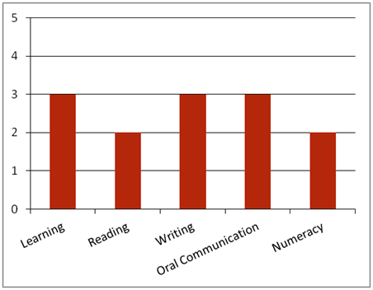FPI20311 Certificate II in Sawmilling and Processing
Note: This graph provides summary information only. For detail, refer to the ACSF Skill indicator table below.
This qualification is designed for job roles in the sawmilling and processing sector of the forest and forest products industry. There are five employment pathways for typical operational environments of sawmilling and processing. These are:
• Kiln Worker
• Timber Grader
• Treatment Plant Worker
• Production Worker
• Sawmill Worker.
Key foundation skills for this qualification
Learning skills to identify and prioritise familiar work tasks; use simple organising methods to select and operate tools, equipment, personal protective and fire extinguishing equipment, and machinery appropriate to work task requirements; use simple strategies to visually inspect products and evaluate their characteristics; apply some prior knowledge to identify OHS issues, fire risks and potential hazards; recognise signs of fire and raise the alarm; eliminate or reduce fire risks and hazards follow incident, accidents and emergency procedures; report breaches or potential breaches; and with assistance, identify and establish opportunities for professional development.
- Training activities in this area could support the delivery of FSKLRG05 Use strategies to plan simple workplace activities, FSKLRG09 Use strategies to respond to routine work problems or FSKLRG11 Use routine strategies for work related learning.
Reading skills to identify key information in OHS, environmental, legislative and organisational requirements; interpret familiar and routine work orders, environmental care requirements, safe operating and quality workplace procedures, product specifications and manufacturer’s recommendations; and decode work signage and visual communications.
- Training activities in this area could support the delivery of FSKRDG07 Read and respond to simple workplace information, FSKRDG06 Read and respond to routine simple informal workplace texts or FSKRDG05 Read and respond to simple workplace information.
Writing skills to convey routine instructions using communication modes such as memos, MSDS, charts and plans; use familiar manual or computer-based formats to record fire prevention procedures, breaches or potential breaches, drying and treatment requirements and quality and product care procedures; produce routine records of emergency and evacuation procedures; conduct reporting via email, written notes; complete simple workplace proformas or documents, such as hazard, accident or incident reports; and record learning and competency development information.
- Training activities in this area could support the delivery of FSKWTG06 Write simple workplace information or FSKWTG09 Write routine workplace texts.
Oral communication skills to check legal and procedural requirements and own work role and responsibilities with relevant personnel; receive and respond to verbal instructions and conduct verbal reporting on routine matters such as breaches, potential breaches, risks, hazards, OHS issues, and emergency and evacuation procedures; seek appropriate support, including mentoring, coaching and feedback on performance; clarify work order with fire warden, supervisor, clients and suppliers; consult appropriate personnel about opportunities for professional development; participate in simple meeting processes; and communicate with co-workers using language and mannerisms that are socially and culturally acceptable.
- Training activities in this area could support the delivery of FSKOCM03 Participate in simple spoken interactions at work or FSKOCM07 Interact effectively with others at work.
Numeracy skills to maintain and adjust machinery and equipment; check product specifications, including industry standard cross sections and lengths; monitor product recovery to minimise waste by maximising resource use; and evaluate product density; access and interpret routine information such as delivery dockets, MSDS, maps, work schedules and job risk assessments; use electronic and mechanical signal to apply visual communications; and interpret information found in graphical instructions, charts, hand drawings, maps, diagrams, sketches and graphics.
- Training activities in this area could support the delivery of FSKNUM09 Identify, measure and estimate familiar quantities for work, FSKNUM11 Read and use familiar maps and plans and diagrams for work.
ACSF Skill indicators
Core units |  | Learning |  | Reading |  | Writing |  | Oral Comm |  | Numeracy
FPICOR2201B | Work effectively in the forest and forest products industry | 2.01 | 2.02 | 2.03 | 2.04 | 2.05 | 2.06 | 3.07 | 3.08 | - | - | -
FPICOR2205B | Follow OHS policies and procedures | 3.01 | 3.02 | 2.03 | 2.04 | 3.05 | 3.06 | 3.07 | 3.08 | - | - | -
FPIC0R2202B | Communicate and interact effectively in the workplace | 2.01 | 2.02 | 2.03 | 2.04 | 2.05 | 2.06 | 3.07 | 3.08 | 2.09 | 2.10 | -
FPICOR2203B | Follow environmental care procedures | 3.01 | 3.02 | 2.03 | 2.04 | 2.05 | 2.06 | 3.07 | 3.08 | - | - | -
FPICOR2207B | Maintain quality and product care | 2.01 | 2.02 | 2.03 | 2.04 | 2.05 | 2.06 | 2.07 | 2.08 | - | - | -
FPICOR2204B | Follow fire prevention procedures | 3.01 | 3.02 | 2.03 | 2.04 | 3.05 | 3.06 | 2.07 | 2.08 | -
Performance Variables
Level 2 simple familiar texts and vocabulary with clear purpose; with support available if requested; a limited range of contexts; and limited steps in the work process.
Level 3 routine texts; working independently in a range of familiar contexts in tasks involving a number of steps in the work process.

