ACSF qualification summary for:
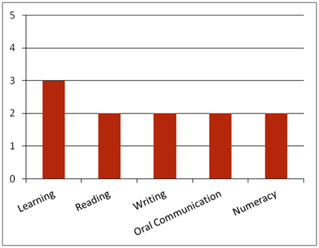FPP20110 Certificate II in Papermaking Operations
Note: This graph provides summary information only. For detail, refer to the ACSF Skill indicator table below.
This qualification is designed for operational job roles in the papermaking sector of the forest and forest products industry.
Key foundation skills for this qualification
Learning skills to identify and prioritise familiar work tasks; use organising methods to monitor control points; apply some prior knowledge to identify faulty equipment and out-of-standard performance and/or products; prioritise need for corrective action based on potential risk/ loss/ damage; conduct corrective action, including making adjustments according to Standard Operating Procedures to ensure specified product quality; and plans and implements processes to treat non-conforming products.
- Training activities in this area could support the delivery of FSKLRG05 Use strategies to plan simple workplace activities, FSKLRG09 Use strategies to respond to routine work problems or FSKLRG11 Use routine strategies for work related learning.
Reading skills to identify key information in OHS, environmental, legislative and organisational requirements; and interpret product information.
- Training activities in this area could support the delivery of FSKRDG07 Read and respond to simple workplace information, FSKRDG06 Read and respond to routine simple informal workplace texts or FSKRDG05 Read and respond to simple workplace information.
Writing skills to record routine quality inspections using simple forms or checklists; and process variable values and/or test information using familiar workplace forms.
- Training activities in this area could support the delivery of FSKWTG06 Write simple workplace information.
Oral communication skills to report out-of-standard performance using familiar workplace terminology; and report faulty equipment to appropriate personnel.
- Training activities in this area could support the delivery of FSKOCM03 Participate in simple spoken interactions at work.
Numeracy skills to identify and report out-of-standard performance by interpreting numerical readings; and interpret production information, including quantities.
- Training activities in this area could support the delivery of FSKNUM09 Identify, measure and estimate familiar quantities for work, FSKNUM11 Read and use familiar maps and plans and diagrams for work.
ACSF Skill indicators
Core units |  | Learning |  | Reading |  | Writing |  | Oral Comm |  | Numeracy
FPPQAS210A | Apply basic quality practices | 3.01 | 3.02 | 2.03 | 2.04 | 2.05 | 2.06 | 2.07 | 2.08 | 2.09 | 2.10 | 2.11
Performance Variables
Level 2 simple familiar texts and vocabulary with clear purpose; with support available if requested; a limited range of contexts; and limited steps in the work process.
Level 3 routine texts; working independently in a range of familiar contexts in tasks involving a number of steps in the work process.

