ACSF qualification summary for:
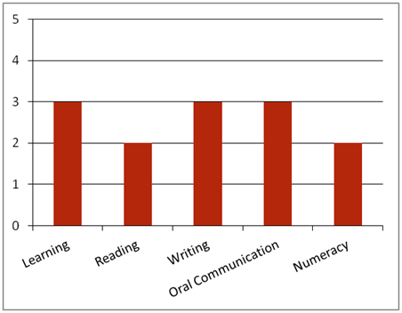FPI20111 Certificate II Forest Growing and Management
Note: This graph provides summary information only. For detail, refer to the ACSF Skill indicator table below.
This qualification is designed for job roles in the forest growing and management sector of the forest and forest products industry.
Key foundation skills for this qualification
Learning skills to identify and prioritise work tasks; follow work plans; select and use appropriate equipment; identify and establish opportunities for professional development; identify and follow correct procedures and processes, including environmental care procedures; Identify environmental risks and hazards.
- Training activities in this area could support the delivery of FSKLRG05 Use strategies to plan simple workplace activities, FSKLRG09 Use strategies to respond to routine work problems or FSKLRG11 Use routine strategies for work related learning.
Reading skills to read and interpret work instructions; key information in OHS, environmental, legislative and organisational requirements; read signage; read and interpret procedures; MSDS, organisational forms and communications.
- Training activities in this area could support the delivery of FSKRDG07 Read and respond to simple workplace information, FSKRDG06 Read and respond to routine simple informal workplace texts or FSKRDG05 Read and respond to simple workplace information.
Writing skills to complete workplace forms, participate in workplace communication (such as email); record workplace information (such as breaches of regulations, meeting notes) using the appropriate forms.
- Training activities in this area could support the delivery of FSKWTG06 Write simple workplace information or FSKWTG09 Write routine workplace texts.
Oral communication skills to give and receive workplace instructions, clarify meaning of instructions with appropriate personnel; use communication equipment (such as radio, phone); provide verbal reports; report potential environmental risks and hazards; participate in meetings (make constructive contributions and respond appropriately to others); suggest improvements to work practices; seek feedback on work performance and competency development.
- Training activities in this area could support the delivery of FSKOCM03 Participate in simple spoken interactions at work or FSKOCM07 Interact effectively with others at work.
Numeracy skills to interpret work instructions that may include graphic information; access and interpret information located in MSDS, maps, charts; diagrams and sketches.
- Training activities in this area could support the delivery of FSKNUM09 Identify, measure and estimate familiar quantities for work, FSKNUM11 Read and use familiar maps and plans and diagrams for work.
ACSF Skill indicators
Core units |  | Learning |  | Reading |  | Writing |  | Oral Comm |  | Numeracy
FPICOR2201B | Work effectively in the forest and forest products industry | 2.01 | 2.02 | 2.03 | 2.04 | 2.05 | 2.06 | 3.07 | 3.08 | - | - | -
FPICOR2202B | Communicate and interact effectively in the workplace | 2.01 | 2.02 | 2.03 | 2.04 | 2.05 | 2.06 | 3.07 | 3.08 | 2.09 | 2.10 | -
FPICOR2203B | Follow environmental care procedures | 3.01 | 3.02 | 2.03 | 2.04 | 2.05 | 2.06 | 3.07 | 3.08 | - | - | -
FPICOR2204B | Follow fire prevention procedures | 3.01 | 3.02 | 2.03 | 2.04 | 3.05 | 3.06 | 2.07 | 2.08 | - | - | -
FPICOR2205B | Follow OHS policies and procedures | 3.01 | 3.02 | 2.03 | 2.04 | 3.05 | 3.06 | 3.07 | 3.08 | - | - | -
Performance Variables
Level 2 simple familiar texts and vocabulary with clear purpose; with support available if requested; a limited range of contexts; and limited steps in the work process.
Level 3 routine texts; working independently in a range of familiar contexts in tasks involving a number of steps in the work process.
Ratings may incorporate some tasks carried out at lower levels.

