ACSF qualification summary for:
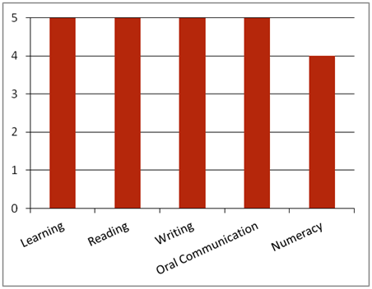FPI6011 Advanced Diploma Forest Industry Sustainability
Note: This graph provides summary information only. For detail, refer to the ACSF Skill indicator table below.
This qualification is designed for supervisory and leadership job roles in the forest and forest products industry.
Key foundation skills for this qualification
Learning skills to assess existing workplace policies and procedures; research and define scope of sustainability requirements for the workplace; make recommendations and give feedback based on research outcomes; review and revise policies; agree on appropriate strategies for implementation; manage policy implementation, including establishing processes to facilitate policy implementation; evaluate changing trends and opportunities for improved workplace sustainability; monitor reports for feedback that supports continuous improvement of procedures; regularly evaluate and modify policy to reflect ongoing improvements; develop and implement a value maximisation plan; establish processes to monitor the implementation of the plan; coordinate the required technology, materials Monitor and review maximisation value plan; identify market demand for wood residue products.
- Training activities in this area could support the delivery of FSKLRG12 Apply strategies to plan and manage complex workplace tasks.
Reading skills to evaluate OHS, environmental, legislative and organisational requirements; critically reflect on existing policies and procedures for the workplace in relation to sustainability requirements; identify and follow OHS, environmental, best practices, standards, legislative and organisational requirements; review management plans and priorities.
- Training activities in this area could support the delivery of FSKRDG12 Read and respond to highly complex workplace information.
Writing skills to develop a draft policy for circulation to stakeholders; design policy that reflects the organisation’s commitment to sustainability; document appropriate strategies for implementation; regularly modify policy ; develop a value maximisation plan, including a methodology, schedule, budget and legislative requirements; record and report outcomes to appropriate personnel; prepare improvement recommendations using ; document applications and demand for wood and residue materials; document product value chain.
- Training activities in this area could support the delivery of FSKWTG11 Write highly complex workplace texts.
Oral communication skills to conduct consultations with stakeholders, including customers, investors, government, regulators, specialists, key personnel, local community; communicate appropriate strategies for implementation to stakeholders; establish timelines and budget with appropriate personnel; receive feedback; inform those involved in implementation as to expected outcomes; assign responsibilities to those involved in implementation; communicate production schedule to appropriate personnel.
- Training activities in this area could support the delivery of FSKFSKOCM08 Use oral communication skills to facilitate workplace negotiations.
Numeracy skills to establish timelines and budget with appropriate personnel; establish targets and indicators to maximise policy outcomes; analyse data on enterprise resource consumption; analyse qualitative and quantitative data to develop a value maximisation plan; monitor and determine the effectiveness of the plan; prepare improvement recommendations; establish targets and indicators to maximise policy outcomes; analyse data on enterprise resource consumption.
- Training activities in this area could support the delivery of FSKNUM22 Use and apply ratios, rates and proportions for work or FSKNUM21 Apply an expanding range of mathematical calculations for work.
ACSF Skill indicators
Core units |  | Learning |  | Reading |  | Writing |  | Oral Comm |  | Numeracy
FPICOR6201A | Manage sustainability in the workplace | 5.01 | 5.02 | 5.03 | 5.04 | 5.05 | 5.06 | 5.07 | 5.08 | 4.09 | 4.10 | 4.11
FPICOR6202A | Implement practices to maximise value from the wood residues | 5.01 | 5.02 | 5.03 | 5.04 | 5.05 | 506 | 4.07 | 4.08 | 4.09 | 4.10 | 4.11
Performance Variables
Level 2 simple familiar texts and vocabulary with clear purpose; with support available if requested; a limited range of contexts; and limited steps in the work process.
Level 3 routine texts; working independently in a range of familiar contexts in tasks involving a number of steps in the work process.

